**TCP vs UDP: Class Notes**

**Transmission Control Protocol (TCP)**

* **Connection-Oriented**: Establishes a reliable connection using a three-way handshake before data transmission.
* **Reliability**: Ensures data delivery through acknowledgments, sequencing, and retransmission of lost packets.
* **Data Ordering**: Maintains the order of data packets, ensuring they arrive in the sequence sent.
* **Error Checking**: Employs checksums for error detection and correction.
* **Flow & Congestion Control**: Manages data flow and network congestion to prevent overload.
* **Use Cases**: Ideal for applications requiring reliable communication, such as web browsing (HTTP/HTTPS), email (SMTP), and file transfers (FTP).

**User Datagram Protocol (UDP)**

* **Connectionless**: Sends data without establishing a prior connection, reducing overhead.
* **Speed**: Faster transmission due to minimal protocol mechanisms.
* **Unreliable Delivery**: No guarantees on data delivery, ordering, or duplication protection.
* **Error Checking**: Includes a simple checksum for error detection; error correction is handled by the application layer if needed.
* **No Flow Control**: Does not manage data flow or congestion, which can lead to packet loss in congested networks.
* **Use Cases**: Suitable for applications where speed is critical and occasional data loss is acceptable, such as video streaming, online gaming, and VoIP.

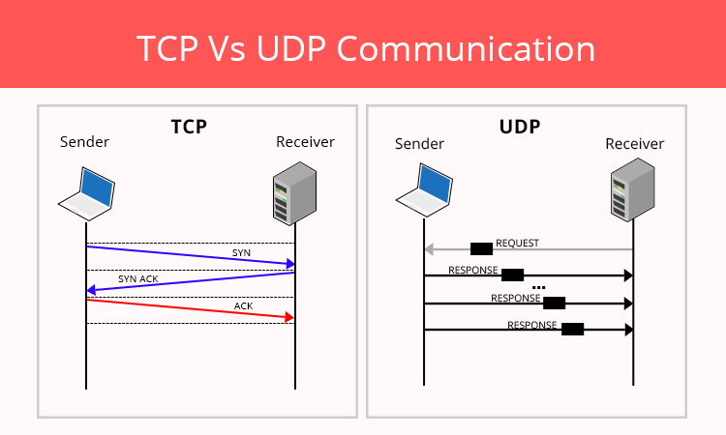

**Summary Comparison**

| **Feature** | **TCP** | **UDP** |
| --- | --- | --- |
| Connection | Connection-oriented | Connectionless |
| Reliability | Reliable (acknowledgments) | Unreliable |
| Data Ordering | Maintains order | No ordering |
| Error Handling | Error detection & correction | Basic error detection |
| Flow Control | Yes | No |
| Speed | Slower due to overhead | Faster with minimal overhead |
| Use Cases | Web, email, file transfers | Streaming, gaming, VoIP |

Understanding the differences between TCP and UDP helps in selecting the appropriate protocol based on the requirements of reliability and speed for various network applications.